**LAB-7:**

**PRELAB:**

1. Solve the CSP problem:

TWO+TWO=FOUR

2. Apply ac1 for the following diagram.

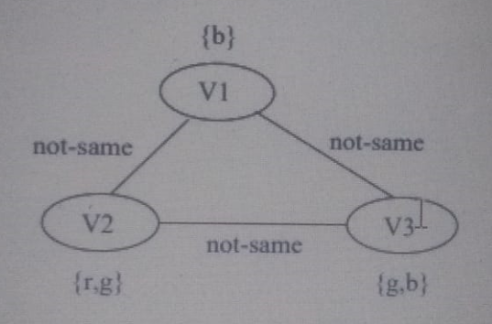

**INLAB:**

1. You have tocolor a map with different colors where no two neighboring regions can have the same color. Assume that you have 5 colors red, blue, green,yellow and pink.Write an efficient python code to color the regions in the following map.

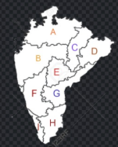

Sample Output:

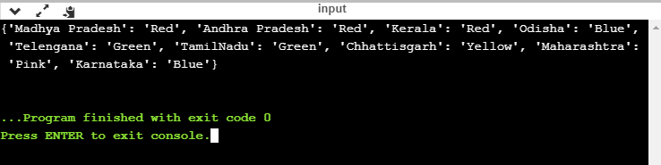

**POSTLAB:**

1. Solve the following problem using Constraint Satisfaction Problems (CSP):

Test Case 1: Magic Square ([[10,11,12], [13, 14, 15], [16, 17, 18]])

False, this is not a magic square. The numbers in the rows/columns/diagonals do not add up to the same value. Let’s try another list of lists.

Test Case 2: Magic Square ([[17,10,15],[12,14,16],[13,18,11]])

True

• Develop a python program that satisfies below operations.

